Functional Specification

FOR
Volunteer Management System (VMS)Volunteer Management System
(VMS)

CLIENT
PROJECT | Volunteer Management System (VMS)Volunteer Management System(VMS) - VMS/T-1.4.1/1Volunteer Management System
TITLE | Functional Specification
VERSION | 0.1c0.1c0.1a
DATE | 16-Aug-2011
 | ORIGINATOR
 | Name / Signature | Team 8S
 | APPROVAL
 | Name / Signature | Phung Kim Cuong, Dio
Institute of Systems Science |  | Document Reference
25 Heng Mui Keng Terrace  Singapore 119615 |  | VMS/T-1.4.1/1

 | Acceptance
 | Customer Signature |  | Customer Signature
 | Name & Designation |  | Name & Designation
 | Date & Company Stamp |  | Date & Company Stamp

Revision History

Date | Version | Description | Author
16-Aug-2011 | 0.1a | Creation | Team 8S
 |  | Refer to amendment history

Table of Contents

1. Use Case Model Survey 5
1.1 Introduction 5
1.2 Survey Description 5
1.3 Actors 5
1.4 Use Case 6
2. UCRR (Analysis) – Security Management 11
2.1 Brief Description 11
2.2 Flow of Events 11
2.3 Standard Flow 11
2.4 Exceptions 13
2.5 Interaction Diagrams 14
2.6 Participating Objects 16
2.7 Class Diagram 17
3. UCRR (Analysis) – Review Project Proposal 19
3.1 Brief Description 19
3.2 Flow of Events 19
3.3 Standard Flow 19
3.4 Exceptions 20
3.5 Interaction Diagrams 21
3.6 Participating Objects 21
3.7 Class Diagram 22
4. UCRR (Analysis) – Manage Itinerary 24
4.1 Brief Description 24
4.2 Flow of Events 24
4.3 Standard Flow 24
4.4 Exceptions 27
4.5 Interaction Diagrams 28
4.6 Participating Objects 30
4.7 Class Diagram 32
5. UCRR (Analysis) – Manage Calendar 34
5.1 Brief Description 34
5.2 Flow of Events 34
5.3 Standard Flow 34
5.4 Exceptions 36
5.5 Interaction Diagrams 37
5.6 Participating Objects 40
5.7 Class Diagram 42
6. UCRR (Analysis) – Review Project Experience 44
6.1 Brief Description 44
6.2 Flow of Events 44
6.3 Standard Flows 44
6.4 Exceptions 44
6.5 Interaction Diagrams 46
6.6 Participating Objects 46
6.7 Class Diagrams 47
7. UCRR (Analysis) – View Project Interest 49
7.1 Brief Description 49
7.2 Flow of Events 49
7.3 Standard Flow 49
7.4 Exceptions 50
7.5 Interaction Diagrams 50
7.6 Participating Objects 51
7.7 Class Diagram 52
8. UCRR (Analysis) – Print Certificate 54
8.1 Brief Description 54
8.2 Flow of Events 54
8.3 Standard Flow 54
8.4 Exceptions 54
8.5 Interaction Diagrams 55
8.6 Participating Objects 55
8.7 Class Diagram 56
9. UCRR (Analysis) – Generate Certificate By Batch 58
9.1 Brief Description 58
9.2 Flow of Events 58
9.3 Standard Flow 58
9.4 Exceptions 59
9.5 Interaction Diagrams 59
9.6 Participating Objects 59
9.7 Class Diagram 60
10. UCRR (Analysis) – Generate Separate Certificate 62
10.1 Brief Description 62
10.2 Flow of Events 62
10.3 Standard Flow 62
10.4 Exceptions 63
10.5 Interaction Diagrams 63
10.6 Participation Objects 63
10.7 Class Diagram 64
11. UCRR (Analysis) – Generate Report 66
11.1 Brief Description 66
11.2 Flow of Events 66
11.3 Standard Flow 66
11.4 Exceptions 66
11.5 Interaction Diagrams 66
11.6 Participating Objects 67
11.7 Class Diagram 68
12. UCRR (Analysis) – Search Project Feedback 70
12.1 Brief Description 70
12.2 Flow of Events 70
12.3 Standard Flow 70
12.4 Exceptions 71
12.5 Interaction Diagrams 71
12.6 Participating Objects 71
12.7 Class Diagram 72
13. UCRR (Analysis) – Search Project Member 74
13.1 Brief Description 74
13.2 Flow of Events 74
13.3 Standard Flows 74
13.4 Exceptions 74
13.5 Interaction Diagrams 76
13.6 Participating Objects 76
13.7 Class Diagram 77
14. UCRR (Analysis) – Search Project Proposal 79
14.1 Brief Description 79
14.2 Flow of Events 79
14.3 Standard Flow 79
14.4 Exceptions 80
14.5 Interaction Diagrams 80
14.6 Participating Objects 80
14.7 Class Diagram 81
ANNEX D Amendment History 82

Use Case Model Survey

Introduction
The purpose this document is to provide a brief description of the project and to describe known actors and their interaction with the system. This document presents a high level view. The main requirements for the system are defined in “User Requirements Specification for Volunteer Management System”, reference VMS/T-1.2/1. The system is to be developed using object-oriented techniques and the Java programming language. For more detailed information, the reader will need to see the individual use case reports.

Survey Description
The scope of this document is to describe the functions that can be performed in the volunteer management system.

Actors

User
This actor represents the general user of the System. The user role can perform login/logout and basic profile update such as Change Password or update details.

Anonymous User
This actor represents public user who have not yet registered as a user of VMS. The Anonymous User can register as a User, or browse the list of projects in the System.

Volunteer
This actor represents a volunteer who is registered and to participate in doing volunteer work at project sites. He can be a project member or project leader for a project site. He will be able to browse for projects and raise interest on projects that he is interested in. He will also be able to post personal experience and feedback regarding a project. He also can request for certification of volunteer work and manage his own profile. Anyone outside the organization can register himself as a volunteer in order to participate in the project site.

Staff
This actor represents organization staffs who work for the volunteer organisation. A staff will be able to perform tasks that a normal user can do. A staff profile will just have different user information compare to volunteer profile.

Administrator
This actor represents a system administrator who manages the user accounts within the system, generate certificates and update system parameters.

Coordinator
This actor represents a project coordinator that participates in reviewing of itinerary and project. Project coordinator also can generate the project report to see the status of certain project.

Project Manager
This actor represents a project manager that is in charge of managing the project sites that has been assigned. He can perform manage the itinerary and calendar for each assigned project site. He also reviews feedback and project interest that has been submitted by volunteers. In addition, PM also performs assignment of volunteers to appropriate projects, submitting project itinerary for reviews or request certificates for the volunteers.

Use Case

Login / Logout
This use case allows the user to login and logout of the system when he wishes to use the system or to exit the system.

Change Password
This use case allows all the users of the system to change their password.

Retrieve Forgotten Password
This use case allows all users of the system to retrieve the password in the event that they have forgotten their password. The password will be email to their registered email.

Register User Account
This use case allows anyone who is interested to become a volunteer to register an account in the system.

Update Profile
This use case allows all the users who have a registered account in the system to update their user profile details. They also can change the password if they want. Refer to use case 4.2 for detail.

Browse Project
This use case allows anyone to browse the list of projects that are within the volunteer organisation. Only certain project information will be visible for public view, certain information will require users to be a registered user to see.

Browse Member of the Project
This use case allows the registered user to browse the member list of projects. Only certain member information will be visible, certain information will require users to be a special role to see.

Propose Project
This use case allows a volunteer or staff to propose a volunteer project to the organisation.

Raise Project Interest
This use case allows a volunteer to raise interest for projects that he is interested in to participate in helping.

Post Project Experience
This use case allows a volunteer to post personal story or interesting experience to share with the public. The experience will go through review and approval before being published for public view.

Post General Feedback
This use case allows a volunteer to post the feedback regarding any matter to the organization.

Request for Certificate
This use case allows a volunteer to request for certificate on the project site that he has participated. It also allows a project manager to request for certificate on behalf of his project team.

Manage Project Details
This use case allows a project manager to manage the details of the project that he is in charge of.

Assign Role to Project Member
This use case allows a project manager to assign volunteers as project members or project leader to the various projects.

Review Feedback
This use case allows a project manager to review and response to feedback that is posted by volunteers.

Review Project Interest
This use case allows a project manager to review a list of requested volunteers who wishes to join a specific project

Send Project Invitation
This use case allows project manager to compile an invitation, and then send it to all volunteers via email, inviting them to join a certain project. The email will contain the link to the page where volunteer can response to the invitation and indicate their preferences. The process to join a project is similar to use case “Raise Project Interest”.

Manage Calendar
This use case allows a project manager to setup a calendar by referencing the approved project itinerary.

Submit Project Itinerary
This use case allows a project manager to submit the prepared itinerary for approval.

Manage Project Itinerary
This use case allows a project manager to search his existing project itinerary, create, update and view a new project itinerary.

Review Project Itinerary
This use case allows a coordinator to search, to review and decide whether to approve or reject a submitted itinerary.

Review Project Proposal
This use case allows a project coordinator to search the list of proposal, to review and to decide whether to approve or reject it. The discussion to approve or reject is done outside the system.

Generate Project Report
This use case allows the project coordinator or project manager to generate reports about the project.

Manage Staff / Volunteer Account
This use case allows the Administrator to register, to view, and to manage the staff account. The Administrator can also manage the volunteer account. Only certain details of these accounts will be modifiable by the administrator.

Generate Certificate
This use case allows the system administrator to generate certificates for multiple volunteers or for individual when there is request of certification from project manager or volunteers.

Configure System Parameter
This use case allows the Administrator to configure certain system-wide parameter that will affect all users.

Overall Use Case Model Survey

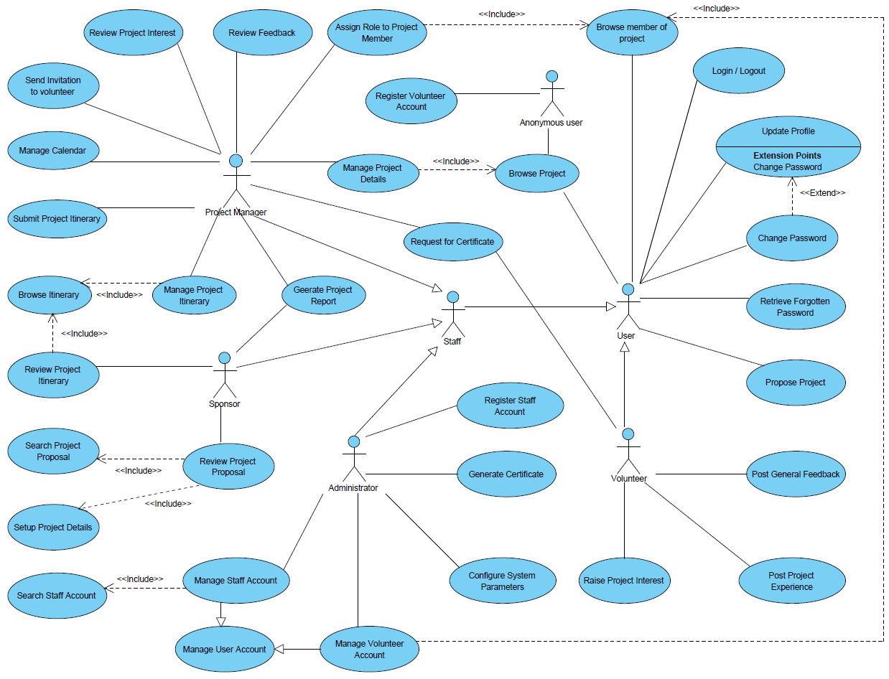

Figure 1 – Overall Use Case Model Survey

Use Case Realisation Report (Analysis) – security MANAGEMENT
FOR
Volunteer Management System (VMS)Volunteer Management System
(VMSVMS)

UCRR (Analysis) – Security Management

Brief Description
The use case describes the security management of VMS system. Registered users can login/logout of the system. Meanwhile, User is able to make changes to password after login. And registered User can also request for a new password when he/she forgets the old password.

Flow of Events
The standard flow of events for this use case and any exceptions are described in the following subsections. See section 3.5 for an overview of the participating Actors and Domain Objects.

Standard Flow
This use case provides the user interface related functionality that will be provided to the User, as follows:

Log-In
To commence using the system functions, the User is required to login as follows:
- When the User clicks ‘Login’ link on the NavMenu, the NavMenu.login() is triggered and it will trigger MainController.redirectURL() method to redirect the system to SecurityScreen.
- MainController.redirectURL() will use SecurityScreen.show() to display an authentication form to enable user to input registered username and password.
- User enters the email address and password on the screen
- When user click ‘submit’ button, the SecurityScreen.onSubmit() method is triggered and it will use SecurityScreen.validFormat() method to perform format checking.
- After format checking, SecurityController.validUserPassword() is triggered to do username and password authentication
- SecurityController.validUserPassword() will first use method User.getAllUsers() method to fetch all the Registered User Objects from data persistence and compare the received username with these objects . If the recived UserName cannot be found, SecurityController.validUserPassword() will use SecurityScreen .displayMsg() operation to instruct the SecurityScreen to display ‘The username has not been registered’.
- If username already exists in the database, SecurityController will use User.ValidatePasswordvalidatePassword() method to compare the received password and the password stored in the object, and return a response to SecurityController informing whether the password is valid or not
- If the password id valid, the SecurityController will use PersonalSecurityScreen.displayMsg() to display ‘Successful login’
- If the password is invalid, the SecurityController will use PersonalSecurityScreen.displayMsg() operation to instruct the SecurityScreen to display ‘Invalid password’.
- Upon a successful login, the system will be redirected to ProjectListingScreen.
- The use case terminates.

Change Password
If the User logs in successfully, he/she will be able to update his/her password as follows:
- When the User clicks ‘Change password’ on the NAVMenu, NAVMenu.ChangePasswordchangePassword() is triggered.
- NAVMenu.ChangePassword() will trigger MainController.redirectURL() to redirect current screen to SecurityScreen.
- After SecurityScreen.show() is triggered, the authentication form will be displayed to enable user to enter old password and new password.
- User will enter the old password and new password. When the user click ‘Change Password’ button, SecurityScreen.OnSubmitonSubmit() is triggered and it will perform the format validation of new password.
- If the format is not valid, SecurityScreen.displayMsg() will be triggered to display ‘Invalid format.’
- Upon the successful validation, the SecurityController.changePassword() will be triggered and it will call the User.getUserbyUserName() method to get the User Object.
- The SecurityController.changePassword() will use the User.validatePassword()to compare the received password with the one in the object.
- If the password is invalid, the securityController SecurityController will use SecurityScreen.displayMsg() to display ‘Incorrect old password.’
- If the old password is valid, the securityController SecurityController will use the method User.setPassword() to set the new password.
- After setting the new password, the securityController SecurityController will use the method SecurityScreen.displayMsg() to display ‘Password has been changed successfully.’
- The use case terminates.

Log-Out
- When the User clicks ‘Log Out’ link on the NAVMenu, NAVMenu.logOut() is triggered and it will trigger MainController.logOut() method
- MainController.logOut() will use SecurityController.logout() to clear the user information
- SecurityController.logout() will clear the current session information of the user.
- Upon the successful logout, SecurityController.logout() will use HomeScreen.show() to redirect the system to the home screen.
- The use case terminates.

Request for New Password
- When the User clicks ‘Request for New Password’ link on the NAVMenu, NAVMenu .requestPassword() is triggered and it will use MainController.redirectURL() to redirect current screen to SecurityScreen.
- MainController.redirectURL() will use SecurityScreen.show() to display the SecurityScreen.
- The input form will be displayed to enable user to enter the username.
- User will enter the username.
- The securityController SecurityController will verify if the user has already registered or not. If not, securityController SecurityController will use the method SecurityScreen.displayMsg() to display ‘User Name does not exist in the system’.
- If yes, the ExchangeServerIF.sendEmail() is triggered and new password will be sent to the user by email.
- The SecurityController verifies if the user has already registered or not. If not, securityController SecurityController will use the method SecurityScreen.displayMsg() to display ‘User Name does not exist in the system.’
- The use case terminates.

Exceptions
The following exceptions have been identified:
- Invalid Password. If User still failed to enter the correct password after ten attempts. The user account will be locked.
- Invalid New Password. If the new password is not conforming to the security format, system will prompt the format tips to assist users.
- Invalid email address. If the email address is not registered, system will display an error message.

Interaction Diagrams

Collaboration Diagram for Login
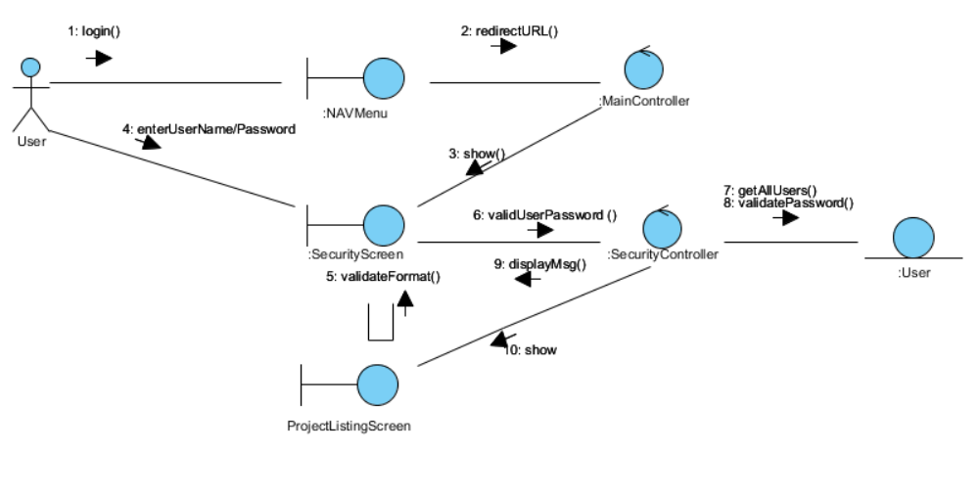

Figure 2 – Collaboration Diagram for Login

Collaboration Diagram for Change Password
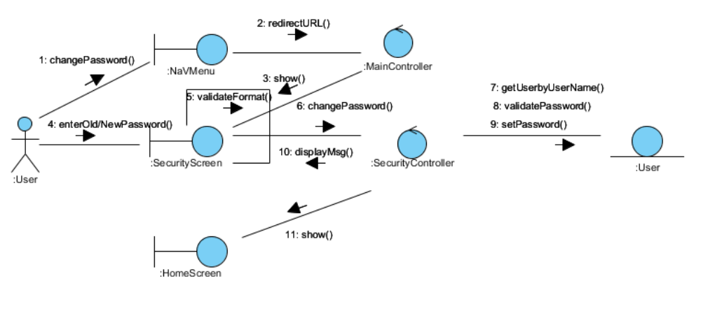

Figure 3 – Collaboration Diagram for Change Password

Collaboration Diagram for Logout
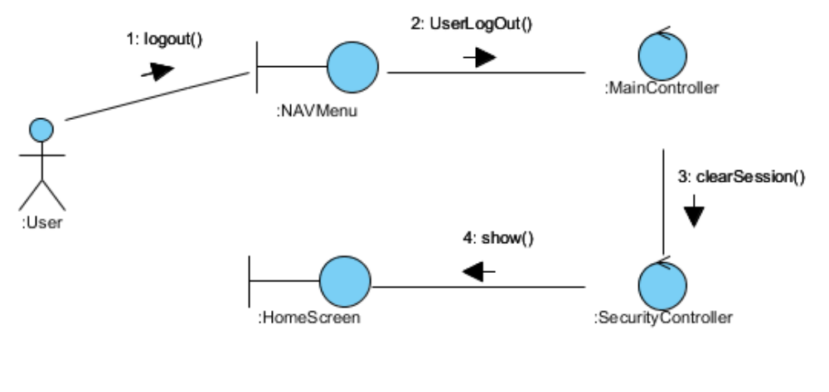

Figure 4 – Collaboration Diagram for Logout

Collaboration Diagram for Request for New Password
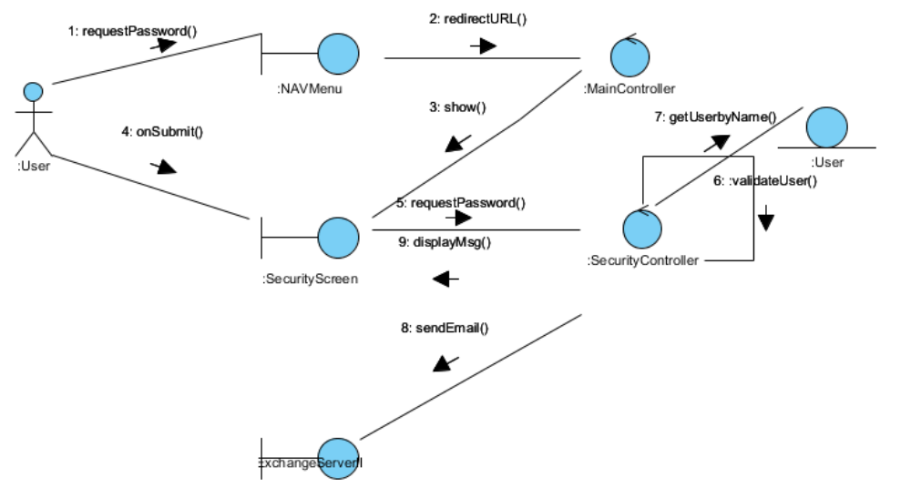

Figure 5 – Collaboration Diagram for Request for New Password

Participating Objects

User
This entity object stores the details concerning a user of the volunteer organisation. The primary attribute that it holds is the userID.

SecurityScreen
This boundary object is used to display security form and exchange security information with controllers.

NAVMenu
This boundary object is used to display system navigation map for user account related operations.

HomeScreen
This boundary object is used for redirecting and displaying of home screen details and menu. All the user actors use this object.

ExchangeServerIF
This boundary object is used to interact with Microsoft Exchange Server and provide email service interfaces.

MainController
This control object co-ordinates the menu selection and dispatches of requests of the volunteer management system. It delegates the user requests to the specific use case control objects for carrying out the use cases.

SecurityController
This control object co-ordinates the authentication, retrieval and update of security information.

Class Diagram
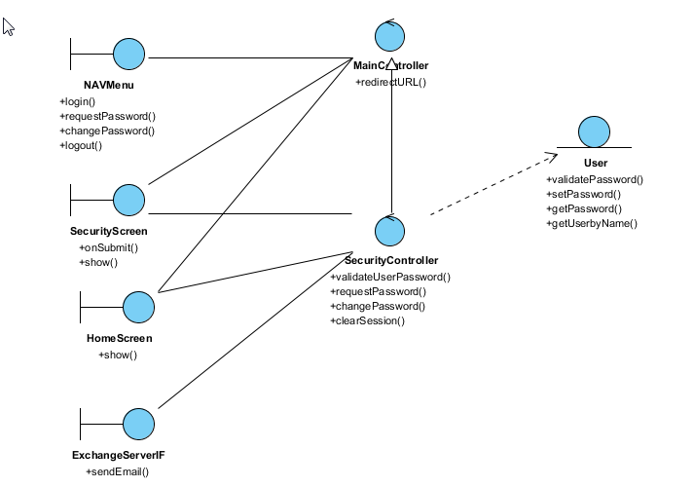

Figure 6 – Class Diagram

Use Case Realisation Report (Analysis) – Review PROJECT PROPOSAL
FOR
Volunteer Management System (VMS)Volunteer Management System
(VMS)

UCRR (Analysis) – Review Project Proposal

Brief Description
The use case enables a Project Coordinator to review the list of project proposal and decide whether to approve or reject the proposal.

Flow of Events
The standard flow of events for this use case and any exceptions are described in the following subsections. See section 4.6 for an overview of the participating Actors and Domain Objects.

Standard Flow
Precondition: User has logged in the system and the user role is project coordinator
The workflow is as below:

Review Project Proposal
- The use case starts when the Coordinator selects the Review Project Proposal menu option from the HomeScreen. The HomeScreen.getProjectProposalScreen() operation is triggered.
- The HomeScreen.getProjectProposalScreen() operation triggers the MainController. getProjectProposalScreen() which delegates to the loadProposalList() operation of the ProposalController.
- The ProposalController will then use the StaffController.getStaffDetails() operation to get an instance of the current logged in staff.
- Then it triggers the getStaff() operation of Staff entity to return an instance of current staff.
- Then the ProposalController will trigger ProjectProposal.getProjectProposal() using the instance of Staff object as parameter to return a list of all project proposal for this current user.
- Then the ProposalController will call the ProjectProposalListingScreen.show() to display the list of project proposal.
- The actor then select a record of proposal and trigger the getProposalDetails operation of the ProjectProposalListingScreen, which in turns delegate to ProposalController.getProposalDetail() operation.
- The ProjectProposalListingScreen.getProposalDetail() operation will call the ProposalController.getProposalDetail() to filter the project proposal list.
- After that, the ProposalController will call the ProposalDetailScreen.show() to display the project proposal record.
- Then the actor can perform the update (reject or approve) the proposal. This action will trigger ProposalDetailScreen.updateProposalDetail()
- Then the ProposalDetailScreen will call the ProposalController.updateProposalDetail() method, which delegate to the ProjectProposal.update() operation
- When the ProjectProposal.update() complete, the ProposalController will display a message via ProposalDetailScreen.showMessage() to inform the actor.
- The use case terminate when the actor click Close button on the ProposalDetailScreen, which trigger ProposalDetailScreen.close() method.

Exceptions
The following exceptions were identified:
- Update fails. If the ProjectProposal.update() operation fails, the project proposal is not updated. An error message will be displayed in the ProposalDetailScreen by the operation ProposalDetailScreen.showMessage().

Interaction Diagrams

Collaboration Diagram for Review Project Proposal
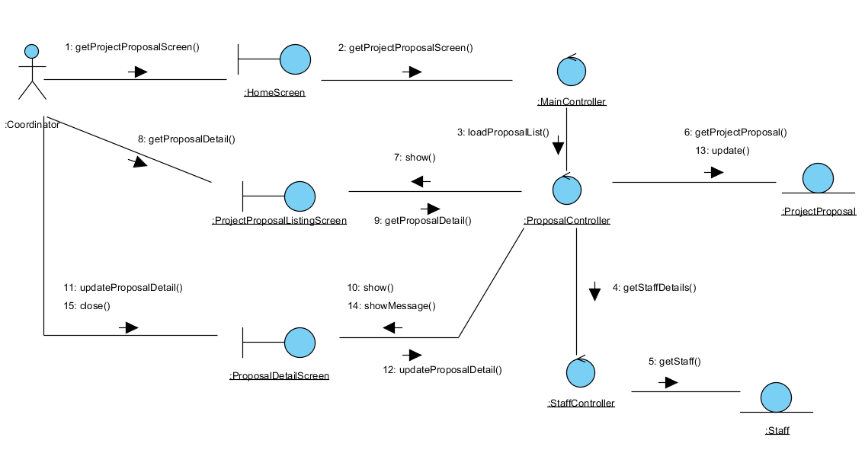

Figure 7 – Review Project Proposal

Participating Objects

Coordinator
This entity object represents the user with a role of Project Coordinator.

HomeScreen
This boundary object represents the home page of VMS.

ProjectProposalListingScreen
This boundary object is used for collection of project proposal listing. User actor uses this object to select and view a project proposal.

ProposalDetailScreen
This boundary object is used for displaying project proposal details. The Coordinator actor interacts with this object.

MainController
This control object co-ordinates the menu selection and dispatches of requests of the volunteer management system. It delegates the user requests to the specific use case control objects for carrying out the use cases.

ProposalController
This control object co-ordinates the update, viewing and searching project proposal record in the system. It receives requests from the boundary objects allocated for the specific purposes, along with all the necessary details required for the execution of these requests.

ProjectProposal
This entity object represents a record of project proposal in the system. It stores all details regarding project proposal.

Staff
This entity object represents a record of staff in the system. It stores all details regarding staff information.

Class Diagram

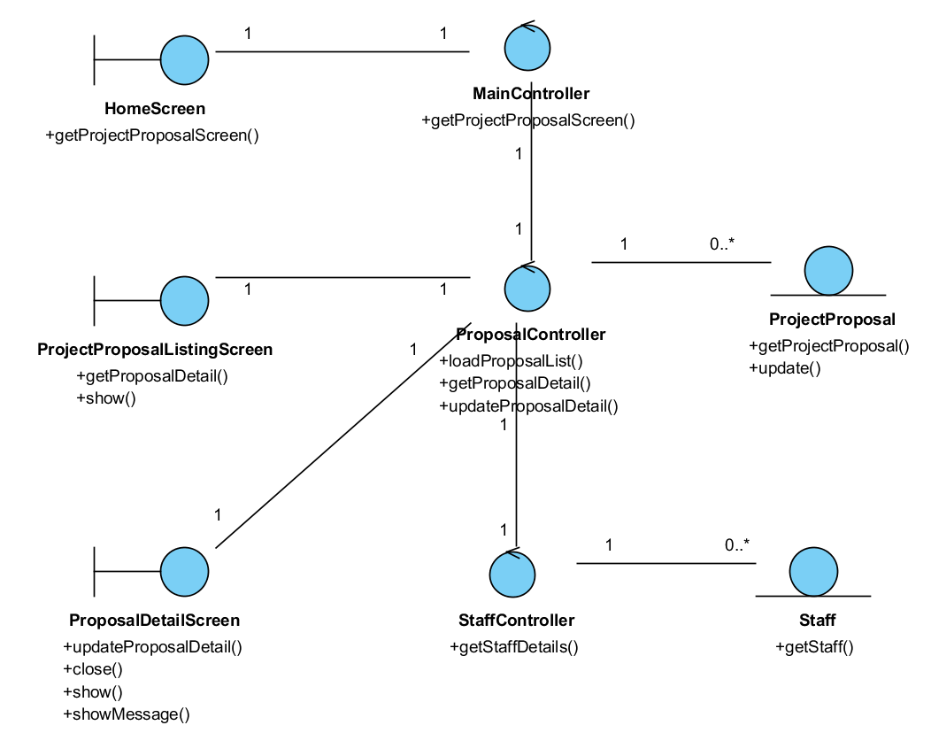

Figure 8 – Class Diagram

Use Case Realisation Report (Analysis) – manage ITINERARY

FOR
Volunteer Management System (VMS)
(VMS)

UCRR (Analysis) – Manage Itinerary

Brief Description
The use case enables a User to view an itinerary of events based on month.

Flow of Events
The standard flow of events for this use case and any exceptions are described in the following subsections. See section 5.6 for an overview of the participating Actors and Domain Objects.

Standard Flow
Precondition: User has logged in the system.
This use case provides the user interface related functionality that will be provided to the Project Manager for interaction with regards to itinerary management, as follows:

List Itinerary
- The use case starts when the User selects the calendar option from the HomeScreen. The HomeScreen.getIntineraryMenu() operation is triggered.
- The getCalendarMenu() operation triggers the MainController.getIntineraryMenu() which delegates to the ItineraryController.getTaskList() operation.
- Using the userID and date, the ItineraryController.getItineraryList() operation triggers Task.getTaskList() operation to retrieve the task records using the userID. The ItineraryController.getItineraryList() operation triggers also triggers the Project.getProject() operation to retrieve the project records based on the projectID that is related to the itineraries.
- The ItineraryController triggers the ItineraryListingScreen.show() operation to display the list of projects by triggering the Task.getTaskList() operation and the Project.getName() operation.
- The use case terminates.

View Itinerary
- The use case starts when the User selects a record to view from the ItineraryListingScreen. The ItineraryListingScreen.getItinerary() operation is triggered.
- Using the taskID, the ItineraryController.getItinerary() operation triggers Task.getTask() operation to retrieve the task details based on the taskID and the Project.getProject() operation is triggered to retrieve the project name for this itinerary.
- The ItineraryController triggers the ViewItineraryScreen.show() operation to display the ViewItineraryScreen by triggering the Task.getAttribute() operation to retrieve the event details and Project.getName() to retrieve the project name.
- The use case terminates.

Create Itinerary
- The use case starts when the Project Manager selects the create event option from the ItineraryListingScreen. The ItineraryListingScreen.getViewCreate() operation is triggered.
- The ItineraryController triggers the CreateItineraryScreen.show() operation to display the CreateItineraryScreen.
- The User enters the task details of the new itinerary into the text fields of CreateItineraryScreen.
- When the User selects the Create button in the form, the CreateItineraryScreen.validate() operation performs form validation based on the input fields.
- Upon successful validation, CreateItineraryScreen.createItinerary() operation triggers the ItineraryController.createItinerary() operation and provides the Task object by triggering the Task.getTask() and Project.getProject() operation to retrieve the project object to get the project ID to create a task. The createTask() operation assigns a new task ID by using the operation Task.getNextTaskID() operation.
- The ItineraryController.createItinerary() operation sets the date of created date of the event which the date is retrieved via the Date.getDate().
- The ItineraryController triggers Task.createTask() operation to create the new Task object details including order number, name, description, duration and status. The system displays an informational message for successfully updated message in the ItineraryListingScreen by triggering the ItineraryListingScreen.showMessage() operation.
- The use case terminates.

Update Itinerary
- The use case starts when the User selects a record to update from the ItineraryListingScreen. The ItineraryListingScreen.getViewUpdate() operation is triggered.
- The ItineraryController.getViewUpdate() operation triggers Task.getTask() operation to retrieve the task details and the Project.getProject() operation is triggered to retrieve the project details related to the task.
- The ItineraryController triggers the ViewItineraryScreen.show() operation to display the UpdateItineraryScreen by triggering the Task.getAttribute() operation and Project.getAttribute() to display the details.
- The User selects the Update button to update the updates the project details of the project into the text fields of UpdateItineraryScreen.
- When the User selects the Update button in the form, the UpdateItineraryScreen.validate() operation performs form validation based on the input fields.
- Upon successful validation, UpdateItineraryScreen.updateItinerary() operation triggers the ItineraryController.updateItinerary() operation and provides the Task object to update the task of the itinerary.
- The ItineraryController triggers Task.updateTask() operation to update the new Task object details ncluding order number, name, description, duration and status. The system displays an informational message for successfully updated message in the ItineraryListingScreen by triggering the ItineraryListingScreen.showMessage() operation
- The use case terminates.

Delete Itinerary
- The use case starts when the Project Manager selects the update project option from the ItineraryListingScreen. The update option is performed by the Update Itinerary use case.
- The Project Manager selects the checkbox for the record(s) that is to be deleted and select Delete button to delete the task. The Update The flow is the same as the Update Itinerary use case with the status updated as Submitted.
- The UpdateItineraryScreen.deleteItinerary() operation triggers the ItineraryController.deleteItinerary() operation and provides the Task object to delete the task(s) of the itinerary.
- The system displays an informational message for successfully deletion in the UpdateItineraryScreen by triggering the UpdateItineraryScreen.showMessage() operation
- The use case terminates.

Submit Itinerary
- The use case starts when the Project Manager selects the update project option from the ItineraryListingScreen. The update option is performed by the Update Itinerary use case.
- The Project Manager selects the Submit button to submit the itinerary to the Project Coordinator for approval. The flow is the same as the Update Itinerary use case with the status updated as Submitted.
- The use case terminates.

Review Itinerary
- The use case starts when the Project Coordinator selects the update project option from the ItineraryListingScreen. The update option is performed by the Update Itinerary use case. However, the Project Coordinator can only view the itinerary and to approve or reject the itinerary.
- The Project Manager selects the Approve or Reject button to submit the itinerary to the Project Coordinator for approval. The flow is the same as the Update Itinerary use case with the status updated as Approved or Rejected (depending on the button selected).
- The use case terminates.

Exceptions
The following exceptions were identified:
- Validation fails. If the CreateItineraryScreen.validate() operation fails, the project creation fails. An error message is displayed in the CreateItineraryScreen by triggering the operation CreateItineraryScreen.showMessage().
- Validation fails. If the UpdateItineraryScreen.validate() operation fails, the project creation fails. An error message is displayed in the UpdateItineraryScreen by triggering the operation UpdateItineraryScreen.showMessage().

Interaction Diagrams

Collaboration Diagram for List Itinerary
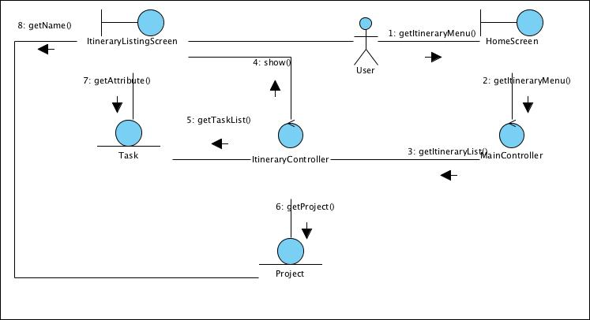

Figure 10 – Collaboration Diagram for List Itinerary

Collaboration Diagram for View Itinerary
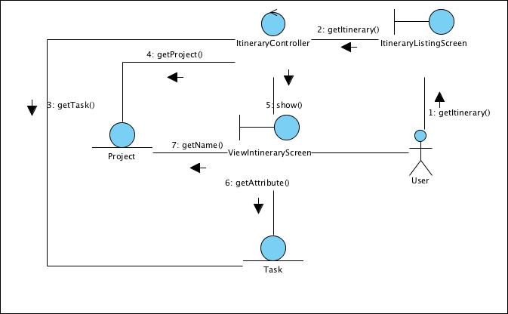

Figure 11 – Collaboration Diagram for View Itinerary

Collaboration Diagram for Create Itinerary
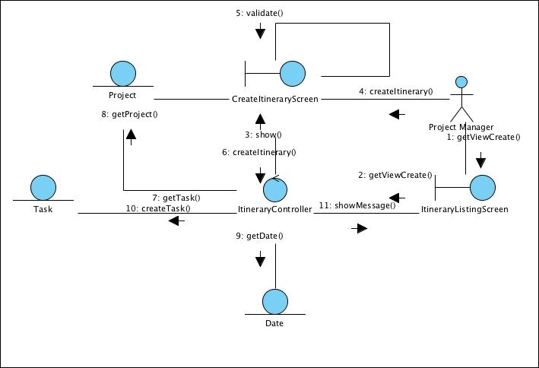

Figure 12 –

Collaboration Diagram for Update Itinerary
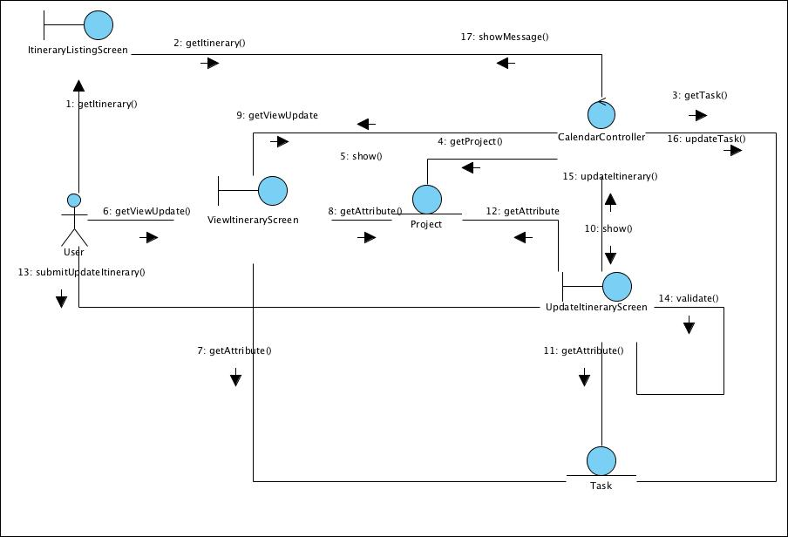

Figure 13 – Collaboration Diagram for Update Itinerary

Collaboration Diagram for Delete Task
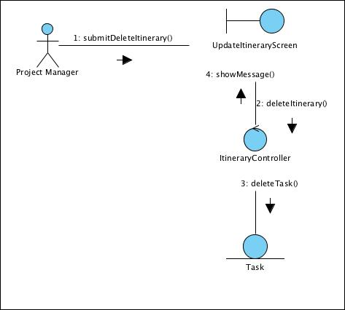

Figure 14 – Collaboration Diagram for Delete Task

Participating Objects

User
This entity object stores the details concerning a user of the volunteer organisation. The primary attribute that it holds is the userID.

Project Manager
This is a Staff object type with a project manager role as an attribute.

Date
This entity object stores the current date.

Task
This entity object stores the details concerning a task of a project’s itinerary. The primary attribute that it holds is the projectID.

Project
This entity object stores the details concerning a task of the volunteer organisation. The primary attribute that it holds is the taskID.

ItineraryListingScreen
This boundary object is used for collection of task listing details. User actor uses this object.

CreateItineraryScreen
This boundary object is used for collection of task details, which a new task record is to be created for the itinerary. The User actor uses this object.

UpdateItineraryScreen
This boundary object is used for collection of task details, which an event record is to be updated. The User actor uses this object.

ViewItineraryScreen
This boundary object is used for collection of task details, which an event record is to be viewed. The User actor uses this object.

HomeScreen
This boundary object is used for redirecting and displaying of home screen details and menu. All the user actors use this object.

MainController
This control object co-ordinates the menu selection and dispatches of requests of the volunteer management system. It delegates the user requests to the specific use case control objects for carrying out the use cases.

ItineraryController
This control object co-ordinates the creation, update and viewing itinerary task record in the volunteer management system. It receives requests from the boundary objects allocated for the specific purposes, along with all the necessary details required for the execution of these requests.

Class Diagram
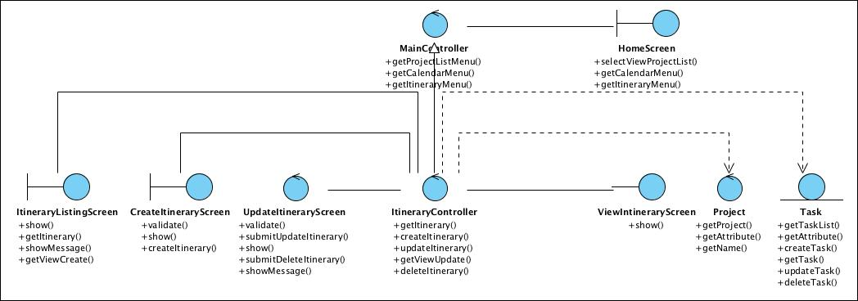

Figure 15 – m

Use Case Realisation Report (Analysis) – manage calendar

FOR
Volunteer Management System (VMS)
(VMS)

UCRR (Analysis) – Manage Calendar

Brief Description
The use case enables a User to view a calendar of events based on month.

Flow of Events
The standard flow of events for this use case and any exceptions are described in the following subsections. See section 6.6 for an overview of the participating Actors and Domain Objects.

Standard Flow
Precondition: User has logged in the system.
This use case provides the user interface related functionality that will be provided to the Project Manager for interaction with regards to calendar management, as follows:

List Event
- The use case starts when the User selects the calendar option from the HomeScreen. The HomeScreen.getCalendarMenu() operation is triggered.
- The getCalendarMenu() operation triggers the MainController.getCalendarMenu() which delegates to the CalendarController.getEventList() operation.
- Using the userID and date, the CalendarController.getEventList() operation triggers Event.getEventList() operation to retrieve the calendar event records using the userID and date. The CalendarController.getEventList() operation triggers also triggers the Attendee.getAttendee() operation to retrieve the attend records based on the eventID.
- The CalendarController triggers the CalendarListingScreen.show() operation to display the list of projects by triggering the Event.getAttribute() operation, Staff.getAttribute() operation and the Project.getProject() operation.
- The use case terminates.

View Event
- The use case starts when the User selects a record to view from the CalendarListingScreen. The CalendarListingScreen.getEvent() operation is triggered.
- Using the eventID, the CalendarController.getEvent() operation triggers Event.getEvent() operation to retrieve the calendar event details based on the eventID and the Attendee.getAttendee() operation is triggered to retrieve the attendees who are participating in the event.
- The CalendarController triggers the ViewCalendarScreen.show() operation to display the ViewCalendarScreen by triggering the Event.getAttribute() operation to retrieve the event details, the Attendee.getAttribute() operation to display the attendees’ details and Project.getName() to retrieve the project name.
- The use case terminates.

Create Event
- The use case starts when the User selects the create event option from the CalendarListingScreen. The CalendarListingScreen.getViewCreate() operation is triggered.
- The CalendarController triggers the CreateCalendarScreen.show() operation to display the CreateCalendarScreen.
- The User enters the calendar event details of the new calendar event into the text fields of CreateCalendarScreen.
- When the User selects the Create button in the form, the CreateCalendarScreen.validate() operation performs form validation based on the input fields.
- Upon successful validation, CreateCalendarScreen.createProject() operation triggers the CalendarController.createEvent() operation and provides the Event object by triggering the Event.getEvent(), retrieves the list of Attendee object by triggering the Attendee.getAttendee() operation and Project.getProject() operation to retrieve the project object to get the project ID to create a event. The createEvent() operation assigns a new event ID by using the operation Event.getNextEventID() operation.
- The CalendarController.createEvent() operation sets the date of created date of the event which the date is retrieved via the Date.getDate().
- The CalendarController triggers Event.createEvent() operation to create the new Event object details including name, description, location, startDate, endDate, attendees and remarks. The system displays an informational message for successfully updated message in the CalendarListingScreen by triggering the CalendarListingScreen.showMessage() operation.
- The use case terminates.

Update Event
- The use case starts when the Project Manager selects a record from the CalendarListingScreen. The CalendarListingScreen.getViewUpdate() operation is triggered.
- The CalendarController.getViewUpdate() operation triggers Attendee.getAttendee() operation to retrieve the attendee details and the Event.getEvent() operation is triggered to retrieve the event details.
- The CalendarController triggers the ViewCalendarScreen.show() operation to display the UpdateCalendarScreen by triggering the Attendee.getAttribute() operation to retrieve the attendee detail, the Event.getAttribute() operation and Project.getAttribute() to display the details.
- The User selects the Update button to update the updates the project details of the project into the text fields of UpdateCalendarScreen.
- When the User selects the Update button in the form, the UpdateCalendarScreen.validate() operation performs form validation based on the input fields.
- Upon successful validation, UpdateCalendarScreen.updateEvent() operation triggers the CalendarController.updateEvent() operation and provides the Event object to update the event.
- The CalendarController triggers Event.updateEvent() operation to update the new Event object details including including name, description, location, startDate, endDate, attendees and remarks. The system displays an informational message for successfully updated message in the CalendarListingScreen by triggering the CalendarListingScreen.showMessage() operation
- The use case terminates.

Publish Event
- The use case starts when the Project Manager selects the update project option from the CalendarListingScreen. The update option is performed by the Update use case.
- The Project Manager checks the checkbox Publish to publish the calendar to the team member’s calendar. The flow is the same as the Update use case with an additional indicator publishIndicator to be updated as Yes.
- The use case terminates.

Exceptions
The following exceptions were identified:
- Validation fails. If the CreateCalendarScreen.validate() operation fails, the project creation fails. An error message is displayed in the CreateCalendarScreen by triggering the operation CreateCalendarScreen.showMessage().
- Validation fails. If the UpdateCalendarScreen.validate() operation fails, the project creation fails. An error message is displayed in the UpdateCalendarScreen by triggering the operation UpdateCalendarScreen.showMessage().

Interaction Diagrams

Collaboration Diagram for List Event
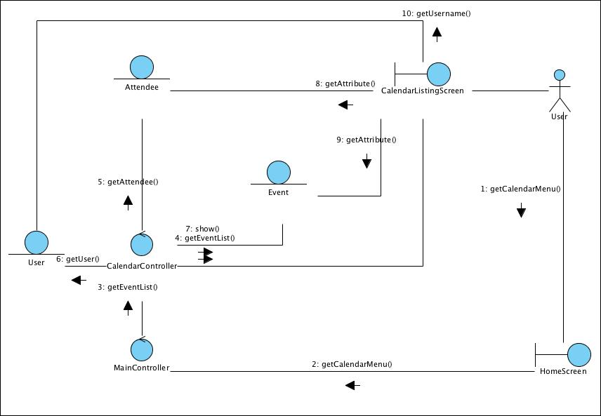

Figure 16 – Collaboration Diagram for List EventCollaboration Diagram for

Collaboration Diagram for View Event
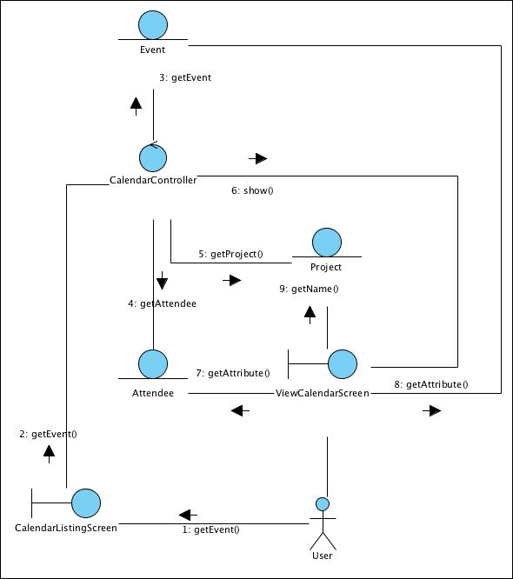

Figure 17 – Collaboration Diagram for View

Collaboration Diagram for Create Event
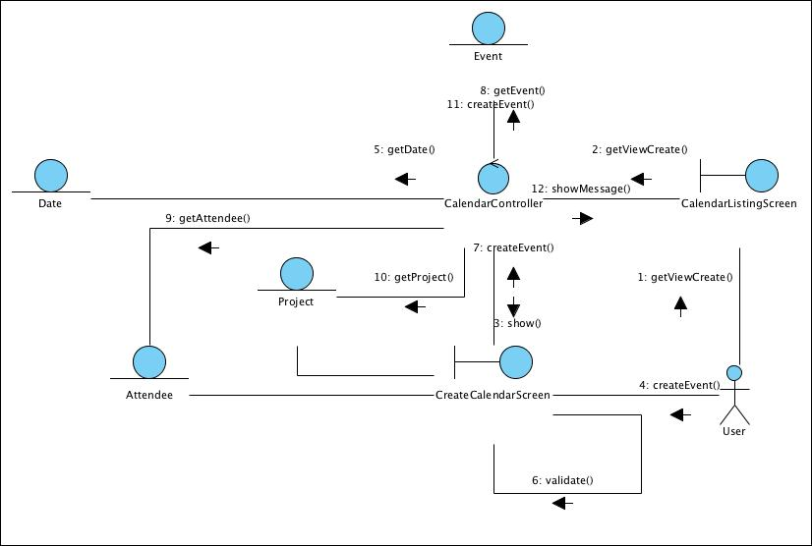

Figure 18 – Collaboration Diagram for Create

Collaboration Diagram for Update Event
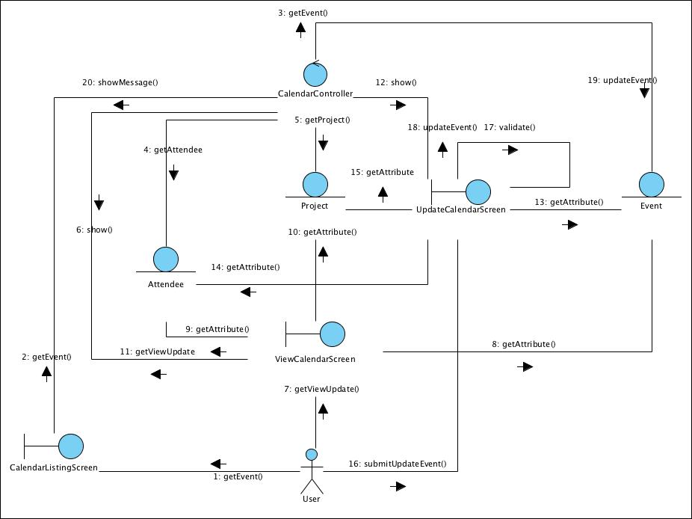

Figure 19 –

Participating Objects

User
This entity object stores the details concerning a user of the volunteer organisation. The primary attribute that it holds is the userID.

Project Manager
This is a Staff object type with a project manager role as an attribute.

Date
This entity object stores the current date.

Event
This entity object stores the details concerning a calendar event of a project’s calendar. The primary attribute that it holds is the projectID.

Attendee
This entity object stores the details concerning an attendee who will be participating in an event. The primary attribute that it holds is the userID.

Project
This entity object stores the details concerning a project of the volunteer organisation. The primary attribute that it holds is the projectID.

CalendarListingScreen
This boundary object is used for collection of event listing details. User actor uses this object.

CreateCalendarScreen
This boundary object is used for collection of event details, which a new event record is to be created. The User actor uses this object.

UpdateCalendarScreen
This boundary object is used for collection of event details, which an event record is to be updated. The User actor uses this object.

ViewCalendarScreen
This boundary object is used for collection of event details, which an event record is to be viewed. The User actor uses this object.

HomeScreen
This boundary object is used for redirecting and displaying of home screen details and menu. All the user actors use this object.

MainController
This control object co-ordinates the menu selection and dispatches of requests of the volunteer management system. It delegates the user requests to the specific use case control objects for carrying out the use cases.

CalendarController
This control object co-ordinates the creation, update and viewing calendar event record in the volunteer management system. It receives requests from the boundary objects allocated for the specific purposes, along with all the necessary details required for the execution of these requests.

Class Diagram
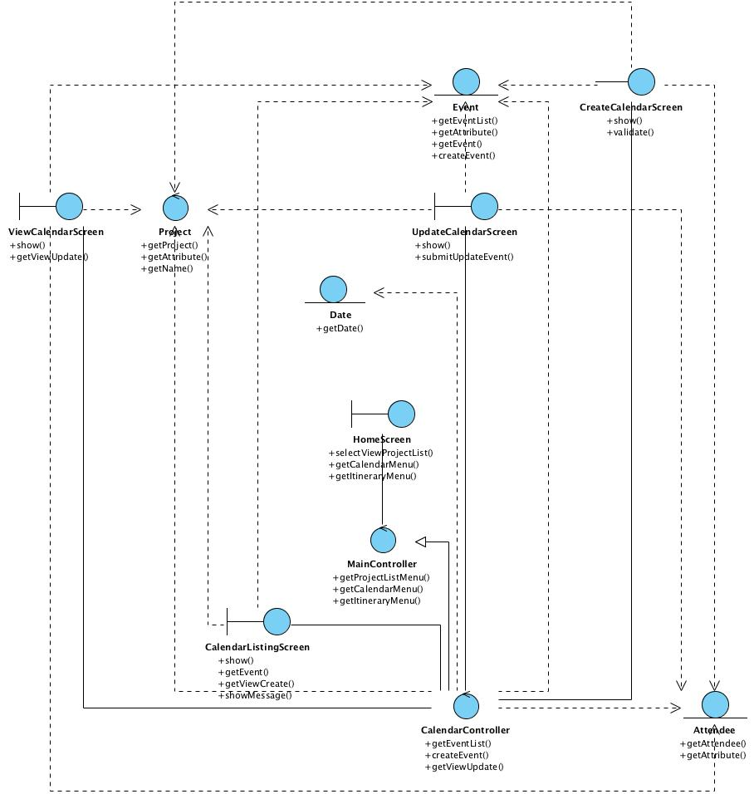

Figure 20 – m

Use Case Realisation Report (Analysis) – review project experience

FOR
Volunteer Management System (VMS)
(VMS)

UCRR (Analysis) – Review Project Experience

Brief Description
The use case enables a Project Manager to review the list of user posted experience regarding the projects under him and decide whether to publish the user-content.

Flow of Events
The standard flow of events for this use case and any exceptions are described in the following subsections. See section 7.6 for an overview of the participating Actors and Domain Objects.

Standard Flows
Precondition: User has logged in the system and the user role is project coordinator
- The use case starts when the Project Manager selects the menu option from the HomeScreen. The HomeScreen. getProjectExperienceScreen() operation is triggered.
- The getProjectExperienceScreen() operation triggers the MainController.getCalendarMenu() which delegates to the CalendarController. reviewProjectExperience() operation.
- Then the MainController delegate to the FeedbackController.getProjectExperience() operation.
- The FeedbackController will then use the StaffController.getStaff() to get a staff profile,which in turn trigger Staff.getStaff().
- With the staff profile, the FeedbackController use the ProjectController.getProjectOfStaff() , which in turn will call the Project.getProject() to return a list of project under this Project Manager.
- With the list of project, the FeedbackController will call the Feedback.getFeedback() to return a list of all user posted project experience regarding the list of projects.
- FeedbackController will then show the list of feedback via the FeedbackDetailScreen.show() method.
- The Project Manager now can review and decide whether to publish the content, which will trigger the updateFeedback() operation of the FeedbackDetailScreen.
- The updateFeedback() operation is in turn trigger the Feedback.update() to store the data. After that the FeedbackController will return a message via FeedbackDetailScreen.sendMessage().

- The use case terminate when the actor click Close button on the FeedbackDetailScreen, which trigger FeedbackDetailScreen.close() method.

Exceptions
The following exceptions were identified:
- Update fails. If the Feedback.update() operation fails, the feedback is not updated. An error message will be displayed in the FeedbackDetailScreen by the operation FeedbackDetailScreen.sendMessage().

Interaction Diagrams

Collaboration Diagram for Review Project Experience
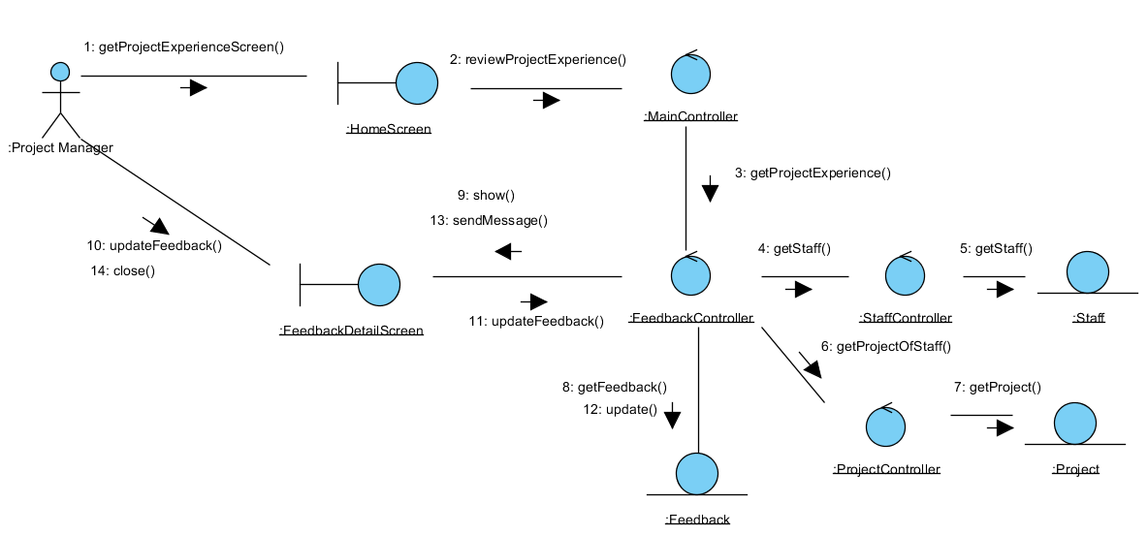

Figure 21 – Collaboration Diagram for Review Project Experience

Participating Objects

Staff
This entity object stores the details concerning a staff of the volunteer organisation. The primary attribute that it holds is the userID.

Project Manager
This is a Staff object type with a project manager role as an attribute.

Project
This entity object stores the details concerning a project of the volunteer organisation. The primary attribute that it holds is the projectID.

Feedback
This entity object stores the details concerning a user posted content inside the volunteer organisation.

FeedbackDetailScreen
This boundary object is used for displaying the details of user posted experience. Project manager interact with this object.

HomeScreen
This boundary object is used for redirecting and displaying of home screen details and menu. All the user actors use this object.

MainController
This control object co-ordinates the menu selection and dispatches of requests of the volunteer management system. It delegates the user requests to the specific use case control objects for carrying out the use cases.

FeedbackController
This control object co-ordinates the creation, update, viewing and searching of feedback in the volunteer management system. It receives requests from the boundary objects allocated for the specific purposes, along with all the necessary details required for the execution of these requests.

Class Diagrams
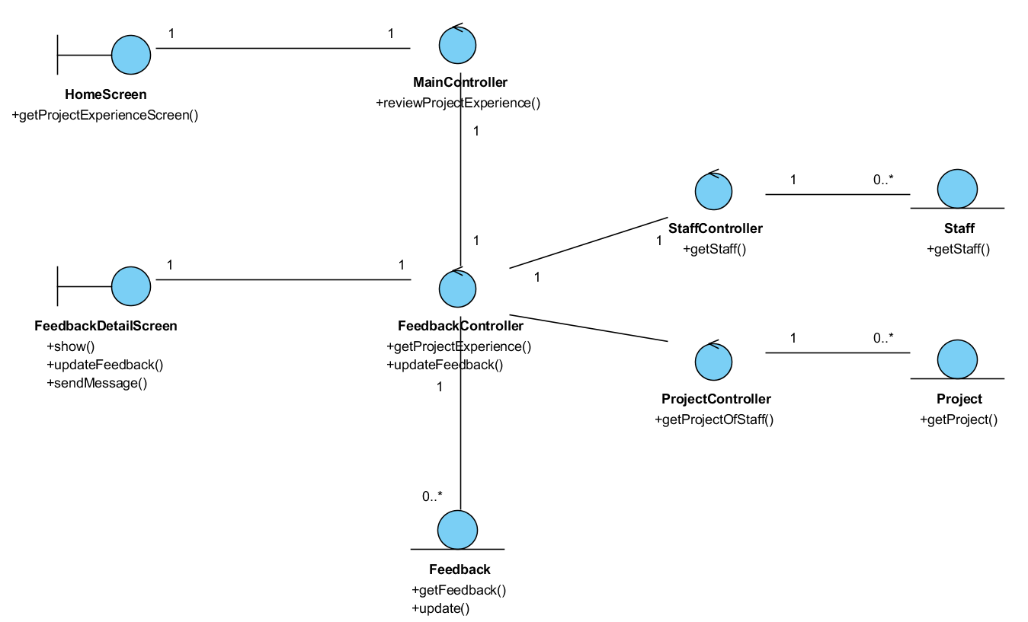

Figure 22 – m

Use Case Realisation Report (Analysis) – view project interest

FOR
Volunteer Management System (VMS)
(VMS)

UCRR (Analysis) – View Project Interest

Brief Description
The use case enables registered user with project manager view the project interest and reply the project interest by accepting or rejecting the project interest raised by the volunteer. If a volunteer’s project interest is accepted by the project manage, that volunteer will become a project member.

Flow of Events
The standard flow of events for this use case and any exceptions are described in the following subsections. See section 8.8 for an overview of the participating Actors and Domain Objects.

Standard Flow

Precondition: Project Manager has logged in the system.
This use case provides the user interface related functionality that will be provided to the User, as follows:
- The use case starts when the project manager selects the Manage Project Interest option from the HomeScreen user interface. The HomeScreen.manageProjectInterest() method is triggered.
- The MenuScreen.manageProjectInterest() triggers the MainController. manageProjectInterest() operation which delegates to ViewProjectInterestScreen. show().
- The show() launches the user interface ViewProjectInterestScreen.
- The project manager uses the ViewProjectInterestScreen user interface to select or key in the project criteria like the project name. When the project manager clicks the Search button in the screen, ViewProjectInterestScreen.enterSearchCriteria() is called.
- The enterSearchCriteria () will triggers the ProjectInterestController.processSearch() to retrieve the list of the project interest that match the criteria.
- The ProjectInterestController.processSearch() will triggers the ProjectFeedback.findProjectInterest() operation to retrieve the list of the project interest that match the criteria.
- After that, ProjectInterestController triggers the ViewProjectInterestScreen.displayResult() operation to display the list of the matching project interest.
- The ViewProjectInterestScreen.displayResult() operation will also triggers the ProjectInterest.getProjectInterest() operation to retrieves the project feedback records.
- The project manager can update the status of each project interest raised by volunteers and click Update button in the ViewProjectInterestScreen screen. ViewProjectInterestScreen.acceptRejectProjectInterest() operation is called.
- The acceptRejectProjectInterest() will triggers the ProjectInterestController.updateProjectInterestStatus() to update the status of the project interests.
- After that, ProjectInterestController triggers the ProjectInterest.updateProjectInterestStatus() operation to update the status of the project interest request.
- ProjectInterestController will triggers the ProjectInterest.getProjectInterestStatus() and Volunteer.getVolunteer() operations to populate the email context.
- ProjectInterestController triggers the EmailServiceController.sendEmail() operation to notify the result of the project interest to the requested volunteers.
- The use case terminates when the project manager click the Close button of the ViewProjectInterestScreen.
- The use case terminates.

Exceptions
The following exceptions have been identified:

- There is no matching project interest: if there is no matching Project Interest for the selected project, the ProjectInterestController will return empty list of Project Interest passing in the displayResult() and the ViewProjectInterestScreen will show an empty list with the “No project interest found” message.

Interaction Diagrams

Collaboration Diagram for View Project Interest

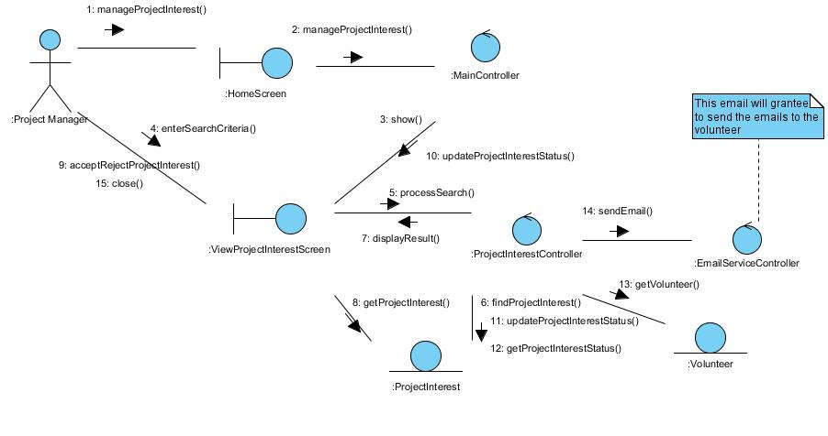

Figure 23 - Collaboration Diagram for View Project Interest

Participating Objects

HomeScreen
This boundary object is used for redirecting and displaying of home screen details and menu. All the user actors use this object.

ViewProjectInterestScreen
The boundary object is used to display the list of volunteer who are interested to join the project and also display the status of whether they are allowed to join the project or not.

ExchangeServerIF
This boundary object is used to interact with Microsoft Exchange Server and provide email service interfaces.

MainController
This control object co-ordinates the menu selection and dispatches of requests of the volunteer management system. It delegates the user requests to the specific use case control objects for carrying out the use cases.

ProjectInterestController
The control object co-ordinates the retrieving of project interest related information based on search criteria from user.

Volunteer
This entity object stores the details concerning a volunteer of the volunteer organisation. The primary attribute that it holds is the userID.

ProjectInterest
This entity object stores the details information of volunteer who are interested to participate in the project.

Class Diagram

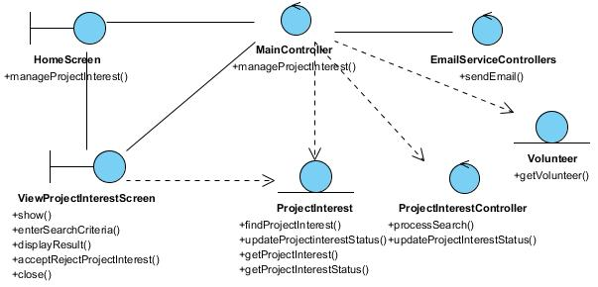

Figure 24 – Class Diagram

Use Case Realisation Report (Analysis) – Print certificate

FOR
Volunteer Management System (VMS)
(VMS)

UCRR (Analysis) – Print Certificate

Brief Description
The use case enables the System Administrator to print certificate of a volunteer for the projects that he/she has participated in.

Flow of Events
The standard flow of events for this use case and any exceptions are described in the following subsections. See section for an overview of the participating Actors and Domain Objects.

Standard Flow
Precondition: GenerateCertificate use case has been executed.
This use case provides the user interface related functionality that will be provided to the System Administrator as follows:
- When the system administrator clicks ‘Print Certificate’ button, the method MainController .printCertificateScreen() is triggered.
- The MainController.printCertificateScreen() will use the method CertificateController.getCertificate() to get the certificate for the specified volunteer.
- CertificateController.getCertificate() will use the Certificate.getCertificateData() method to get Certificate data.
- The PrintCertificate screen will show, and get certificate data for printing.
- The use case terminates.

Exceptions
No exceptions were identified.

Interaction Diagrams

Collaboration Diagram for Print Certificate
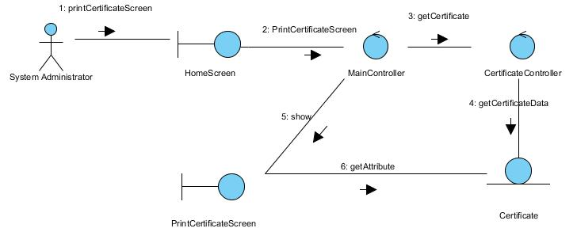

Figure 25 – Collaboration Diagram for Print Certificate

Participating Objects

Certificate
This entity object stores the details concerning a certificate of the volunteer. The primary attribute that it holds is the certificateID.

MainController
This controller object co-ordinates the menu selection and dispatches of requests of the volunteer management system. It delegates the user requests to the specific use case controller objects for carrying out the use cases.

CertificateController
This controler object co-ordinates the printing of the certificate in the volunteer management system. It receives requests from the boundary objects allocated for the specific purposes, along with all the necessary details required for the execution of these requests.

PrintCertificateScreen
This boundary object is used for retrieve the request of printing of certificate. The User actor uses this object.

HomeScreen
This boundary object is used for redirecting and displaying of home screen details and menu. All the user actors use this object.

Class Diagram

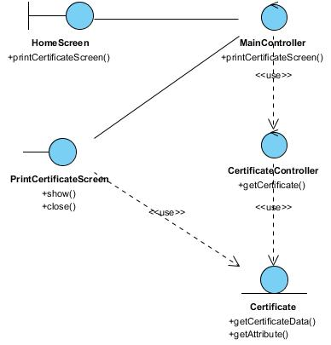

Figure 26 – Class Diagram

Use Case Realisation Report (Analysis) – generate certificate by batch

FOR
Volunteer Management System (VMS)
(VMS)

UCRR (Analysis) – Generate Certificate By Batch

Brief Description
The use case enables registered user with system administrator role to generate batch of certificates requested by project manager for specific project.

Flow of Events
The standard flow of events for this use case and any exceptions are described in the following subsections. See section for an overview of the participating Actors and Domain Objects.

Standard Flow

Precondition: System Administrator has logged in the system and use case 4.6 has been executed.
This use case provides the user interface related functionality that will be provided to the User, as follows:
- The use case starts when the system administrator selects the Generate Certificate option from the HomeScreen user interface. The HomeScreen.getGenerateCertificateScreen() method is triggered.
- The HomeScreen.getGenerateCertificateScreen() triggers the MainController.show() operation which delegates to GenerateCertificateScreen.show().
- The show() launches the user interface GenerateCertificateScreen.
- The system administrator uses the GenerateCertificateScreen user interface to select or key in the certificate criteria like the volunteer name. When the system administrator clicks the Generate Certificate button in the form, GenerateCertificate Screen.enterCertificateCriteria() is called.
- The enterCertificateCriteria() will triggers the CertificateController.generateCertificate() to get the details information of volunteer and project that match the criteria.
- The CertificateController.generateCertificate() will triggers the Volunteer.getVolunteerDetails() operation to retrieve the details information of Volunteer and Project.getProjectDetails() operation to retrieve the details information of Project that match the criteria.
- After that, CertificateController triggers the OpenorSaveDialogbox.showCertificate() operation to get the certificate of requested volunteers for specific project.
- The system administrator uses the OpenorSaveDialogbox user interface to choose save or open option to get the generated certificate.
- The OpenorSaveDialogbox.saveorOpen() operation will also triggers the OpenorSaveDialogbox.close() operation after system administrator choose the option and click OK button.
- The use case terminates.

Exceptions
The following exceptions have been identified:
- There is no matching Certificate: if there is no matching Certificate for the selected project, the CertificateController will return empty data of Certificate and the GenerateCertificateScreen will show “No certificate found” message.

Interaction Diagrams

    - Collaboration Diagram for Generate Certificate By Batch

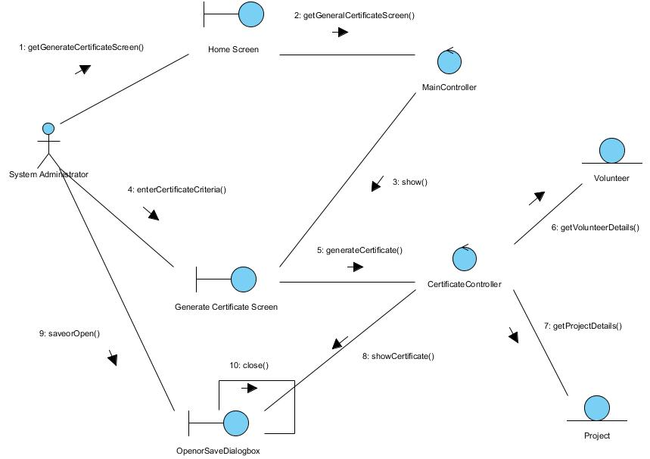

Figure 27 – Collaboration Diagram for Generate Certificate By Batch

Participating Objects

HomeScreen
This boundary object is used to display the main menu of the system. The System Administrator actor uses this object to launch other user interfaces.

MainController
This control object coordinates the menu selection of the VMS system. It delegates the user requests to the specific use case control object for carrying out the use cases.

GenerateCertificateScreen
This boundary object is used to enter certificate criteria of requested volunteer by system administrator.

CertificateController
This control object coordinates the retrieving data of volunteer and project for certificate and generating certificate.

OpenorSaveDialogbox
This boundary object is used to save or open the generated certificate.

Project
This entity object stores all the project related details. This object represents information to be stored on a persistent basis.

Volunteer
This entity object stores all the volunteer details. This object represents information to be stored on a persistent basis.

Class Diagram

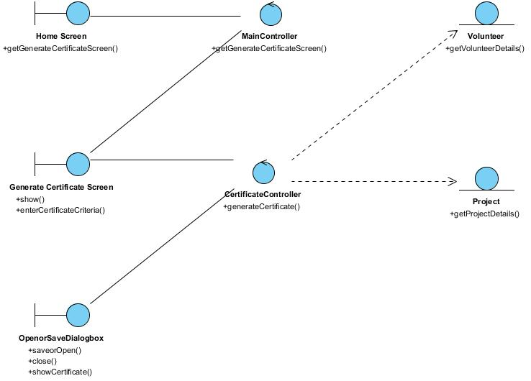

Figure 28 – Class Diagram

Use Case Realisation Report (Analysis) – generate separate certificate

FOR
Volunteer Management System (VMS)
(VMS)

UCRR (Analysis) – Generate Separate Certificate

Brief Description
The use case enables registered user with system administrator role to generate separate certificate requested by volunteer.

Flow of Events
The standard flow of events for this use case and any exceptions are described in the following subsections. See section 11.13 for an overview of the participating Actors and Domain Objects.

Standard Flow

Precondition: System Administrator has logged in the system and use case 4.6 has been executed
This use case provides the user interface related functionality that will be provided to the User, as follows:
- The use case starts when the system administrator selects the Generate Certificate option from the HomeScreen user interface. The HomeScreen.getGenerateCertificateScreen() method is triggered.
- The HomeScreen.getGenerateCertificateScreen() triggers the MainController.show() operation which delegates to GenerateCertificateScreen.show().
- The show() launches the user interface GenerateCertificateScreen.
- The system administrator uses the GenerateCertificateScreen user interface to select or key in the certificate criteria like the volunteer name. When the system administrator clicks the Generate Certificate button in the form, GenerateCertificateScreen.enterCertificateCriteria() is called.
- The enterCertificateCriteria() will triggers the CertificateController.generateCertificate() to get the details information of volunteer and project that match the criteria.
- The CertificateController.generateCertificate() will triggers the Volunteer.getVolunteerDetails() operation to retrieve the details information of Volunteer and Project.getProjectDetails() operation to retrieve the details information of Project that match the criteria.
- After that, CertificateController triggers the OpenorSaveDialogbox.showCertificate() operation to get the certificate of requested volunteer.
- The system administrator use the OpenorSaveDialogbox user interface to choose save or open option to get the generated certificate.
- The OpenorSaveDialogbox.saveorOpen() operation will also triggers the OpenorSaveDialogbox.close() operation after system administrator choose the option and click OK button.
- The use case terminates after the system administrator gets the certificate.

Exceptions
The following exceptions have been identified
- There is no matching Certificate: if there is no matching Certificate for the selected project, the CertificateController will return empty data of Certificate and the GenerateCertificateScreen will show “No certificate found” message.

Interaction Diagrams

    - Collaboration Diagram for Generate Separate Certificate
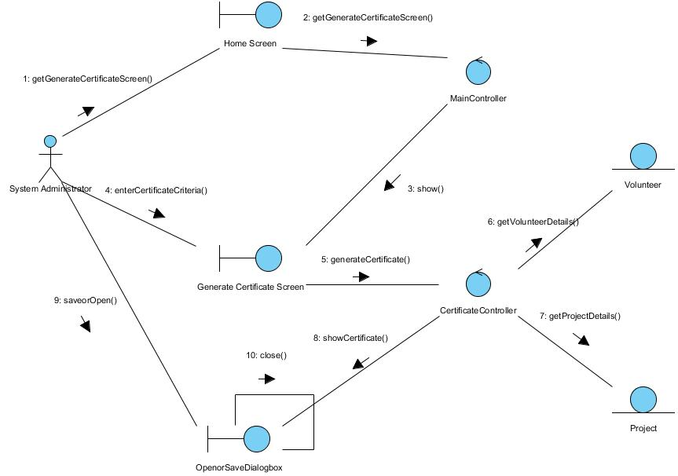

Figure 29 –

Participation Objects

HomeScreen
This boundary object is used to display the main menu of the system. The System Administrator actor uses this object to launch other user interfaces.

MainController
This control object coordinates the menu selection of the VMS system. It delegates the user requests to the specific use case control object for carrying out the use cases.

GenerateCertificateScreen
This boundary object is used to enter certificate criteria of requested volunteer by system administrator.

CertificateController
This control object coordinates the retrieving data of volunteer and project for certificate and generating certificate.

OpenorSaveDialogbox
This boundary object is used to save or open the generated certificate.

Project
This entity object stores all the project related details. This object represents information to be stored on a persistent basis.

Volunteer
This entity object stores all the volunteer details. This object represents information to be stored on a persistent basis.

Class Diagram

Figure 30 – Class Diagram

Use Case Realisation Report (Analysis) – generate Report

FOR
Volunteer Management System (VMS)
(VMS)

UCRR (Analysis) – Generate Report

Brief Description
This use case allows the batch scheduler to generate reports based on predefined schedule.

Flow of Events
The standard flow of events for this use case and any exceptions are described in the following subsections. See section 12.6 for an overview of the participating Actors and Domain Objects.

Standard Flow
This use case provides the functionality that will be provided to the batch scheduler as follows:
- When the user clicks ‘Generate Report’ button, the method MainController .getReportScreen() is triggered.
- The MainController.getReportScreen () will use the method ReportController.getReport() to get the report.
- ReportController.getReport () will use the ReportData.getReportData() method to get Report data.
- The PrintReportScreen will show, and get report data for printing.
- The use case terminates.

Exceptions
No exceptions were identified.

Interaction Diagrams

Collaboration Diagram for Generate Report
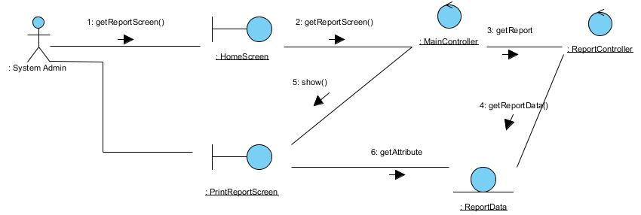

Figure 31 – Collaboration Diagram for Generate Report

Participating Objects

ReportData
This entity object stores the details data concerning a report.

MainController
This controller object co-ordinates the menu selection and dispatches of requests of the volunteer management system. It delegates the user requests to the specific use case controller objects for carrying out the use cases.

ReportController
This controller object co-ordinates the generating of a report in the volunteer management system. It receives requests from the boundary objects allocated for the specific purposes, along with all the necessary details required for the execution of these requests.

PrintReportScreen
This boundary object is used for retrieve the request of printing of report. The User actor uses this object.

HomeScreen
This boundary object is used for redirecting and displaying of home screen details and menu. All the user actors use this object.

Class Diagram
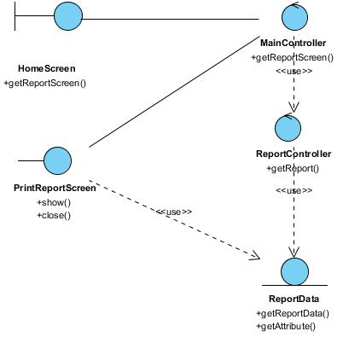

Figure 32 – Class Diagram

Use Case Realisation Report (Analysis) – search project feedback

FOR
Volunteer Management System (VMS)
(VMS)

UCRR (Analysis) – Search Project Feedback

Brief Description
The use case enables registered user with project manager role to search/view the project feedback.

Flow of Events
The standard flow of events for this use case and any exceptions are described in the following subsections. See section for an overview of the participating Actors and Domain Objects.

Standard Flow

Precondition: Project Manager has logged in the system and use case 4.6 has been executed
This use case provides the user interface related functionality that will be provided to the User, as follows:
- The use case starts when the project manager selects the Search Project Feedback option from the MenuScreen user interface. The MenuScreen.selectSearchProjectFeedback() method is triggered.
- The MenuScreen.selectSearchProjectFeedback() triggers the MainController.searchProjectFeedback() operation which delegates to ProjectFeedbackSearchScreen.diplayScreen().
- The displayScreen() launches the user interface ProjectFeedbackSearchScreen.
- The project manager uses the ProjectFeedbackSearchScreen user interface to select or key in the project feedback criteria like the project name. When the project manager clicks the Search button in the form, ProjectFeedbackSearchScreen.enterSearchCriteria() is called.
- The enterSearchCriteria() will triggers the ProjectFeedbackController.processSearch() to retrieve the list of the project feedback that match the criteria.
- The ProjectFeedbackController.processSearch() will triggers the ProjectFeedback.findProjectFeedbackByProject() operation to retrieve the list of the project feedback that match the criteria.
- After that, ProjectFeedbackController triggers the ProjectFeedbackSearchScreen.displayResult() operation to display the list of the matching project feedback.
- The ProjectFeedbackSearchScreen.displayResult() operation will also triggers the ProjectFeedback.getProjectFeedback() operation to retrieves the project feedback records.
- The use case terminates when the project manager click the Close button of the ProjectFeedbackSearchScreen.

Exceptions
The following exceptions have been identified:
- There is no matching project feedback: if there is no matching Project Feedback for the selected project, the ProjectFeedbackController will return empty list of Project Feedback passing in the displayResult() and the ProjectFeedbackSearchScreen will show an empty list with the “No project feedback found” message.

Interaction Diagrams

Collaboration Diagram for Search Project Feedback
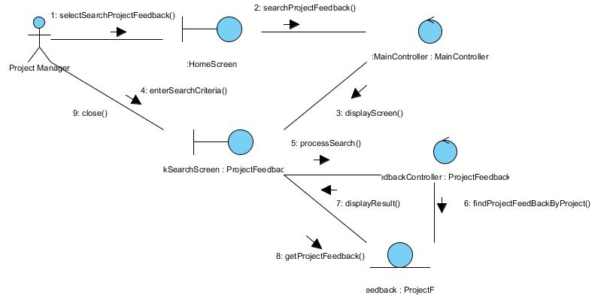

Figure 33 – Collaboration Diagram for Search Project Feedback

Participating Objects

HomeScreen
This boundary object is used for redirecting and displaying of home screen details and menu. All the user actors use this object.

MainController
This control object co-ordinates the menu selection and dispatches of requests of the volunteer management system. It delegates the user requests to the specific use case control objects for carrying out the use cases.

FeedbackController
This control object co-ordinates the ProjectFeedback information update, creation and retrieval.

ProjectFeedback
This entity object stores the details concerning a project feedback.

ProjectFeedbackSearchScreen
This boundary object is used to display project feedback info and allow user to search the project feedback.

Class Diagram

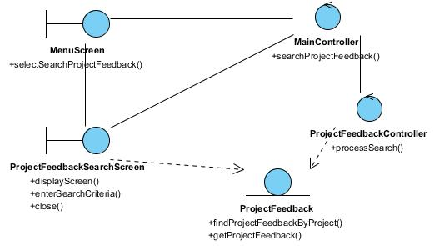

Figure 34 – Class Diagram

Use Case Realisation Report (Analysis) – search project Member

FOR
Volunteer Management System (VMS)
(VMS)

UCRR (Analysis) – Search Project Member

Brief Description
The use case enables any user of the system (can be a volunteer or internal staff) to view the member list of a project. Information display is based on the roles of the user.

Flow of Events
The standard flow of events for this use case and any exceptions are described in the following subsections. See section 15.6 for an overview of the participating Actors and Domain Objects.

Standard Flows
Precondition: User has logged in the system
The workflow is as below:
- The use case starts when the User selects the menu option from the HomeScreen. The HomeScreen.searchProjectMember() operation is triggered.
- The HomeScreen searchProjectMember() operation delegates to the MainController searchProjectMember() operations, which in turn trigger the displaySearchMemberScreen() operation of the MembershipController.
- The MembershipController will then using the UserController.getUserProfile() method to get the current logged in user via the User.getUser().
- Then the MembershipController will trigger ProjectController.getProjectList() to get the list of all projects available for viewing members
- Based on the user profile and the project list, the MembershipController will trigger Membership.getMembership() to return the list of member for each project.
- Then the MembershipController will display the list via MembershipListingScreen show() method.
- The user then key in the search criteria and click Search, which trigger MembershipListingScreen.searchMember() method.
- Using the parameter in searchMember(), the MembershipListingScreen will call the searchMemberByCriteria() method of MembershipController, which then will filter the list and display on the screen via showFilteredResult() method
- User now can see the list of the project member on the MembershipListingScreen, the use case terminates when user click Close button which trigger close() method of the screen.

Exceptions
The following exceptions were identified:
- No result return. If the MembershipController.showFilteredResult() operation does not return any record , the MembershipListingScreen still show with an empty listing for that project.

Interaction Diagrams

Collaboration Diagram for Search Project Member
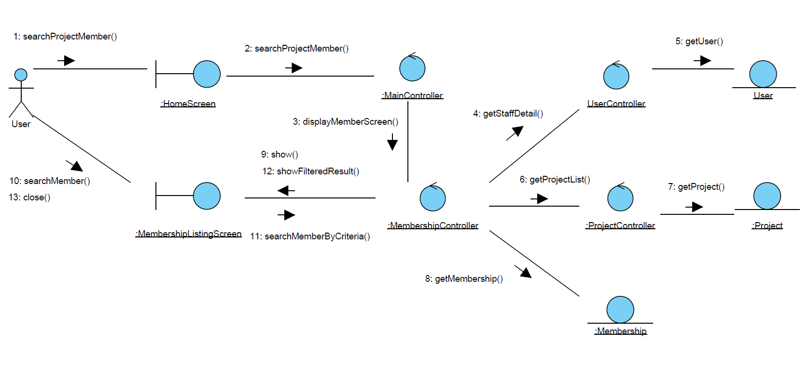

Figure 35 – Search Project Member

Participating Objects

User (Entity)
This entity object represents a registered user of the system, and stores the detailed profile of that user. The primary attribute that it holds is the userID.

User (Actor)
This is a user actor type, which represents anyone who interacts with the system.

Project
This entity object stores the details concerning a project of the volunteer organisation. The primary attribute that it holds is the projectID.

Membership
This entity object stores the details concerning the membership of a volunteer in a project inside the volunteer organisation. The primary attribute that it holds is the membershipID.

MembershipListingScreen
This boundary object is used for displaying a collection of project members. User actor uses this object.

HomeScreen
This boundary object is used for redirecting and displaying of home screen details and menu. All the user actors use this object.

MainController
This control object co-ordinates the menu selection and dispatches of requests of the volunteer management system. It delegates the user requests to the specific use case control objects for carrying out the use cases.

MembershipController
This control object co-ordinates the creation, update, viewing and searching project record in the volunteer management system. It receives requests from the boundary objects allocated for the specific purposes, along with all the necessary details required for the execution of these requests.

UserController
This controller object co-ordinate the operations on a user profile (searching, viewing, creating of user profile). In this use case it will be in charge of getting the user profile details.

ProjectController
This controller object co-ordinate the operations on a project entity (searching, viewing, creating, updating). In this use case it will be in charge of getting the project entity details.

Class Diagram

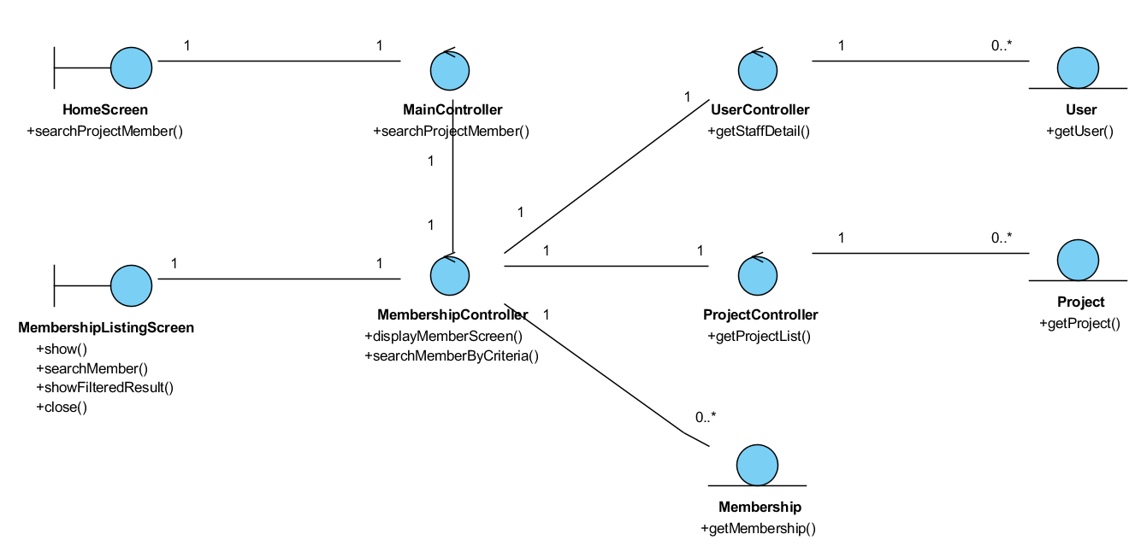

Figure 36 –Class Diagram

Use Case Realisation Report (Analysis) – search project proposal

FOR
Volunteer Management System (VMS)
(VMS)

UCRR (Analysis) – Search Project Proposal

Brief Description
The use case enables a Project Coordinator to view the list of project proposal.

Flow of Events
The standard flow of events for this use case and any exceptions are described in the following subsections. See section 3.1 for an overview of the participating Actors and Domain Objects.

Standard Flow
Precondition: User has logged in the system and the user role is project coordinator
The workflow is as below:
- The use case starts when the Coordinator selects the menu option from the HomeScreen. The HomeScreen.getProjectProposalScreen() operation is triggered.
- The getProjectProposalScreen() operation triggers the MainController. getProjectProposalScreen() which delegates to the loadProposalList() operation of the ProposalController
- Then the ProposalController trigger the getStaffDetails() operation of the StaffController, which in turn call the getStaff() operation from the corresponding entity.
- Using the staff profile, the ProposalController triggers the getProjectProposal() from the corresponding ProjectProposal entity.
- Now the coordinator see the list of project proposal belongs to him, he can perform a search on the ProjectProposalListingScreen.search() method
- This method will trigger the ProposalController.searchByCriteria(), then the ProposalController return the result via ProjectProposalListingScreen showFilteredResult() operation
- The use case terminates when the user select Close button which trigger close() method on ProjectProposalListingScreen.

Exceptions
No exception has been identified.

Interaction Diagrams

Collaboration Diagram for Search Project Proposal
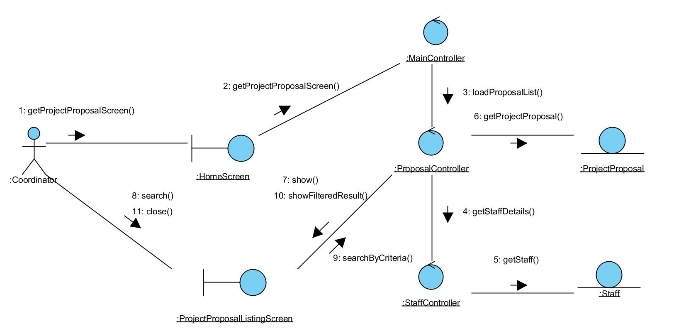

Figure 37 – Search Project Proposal

Participating Objects

Staff
This entity object stores the details concerning a staff of the volunteer organisation. The primary attribute that it holds is the userID.

Coordinator
This is an actor type, which represents a user with coordinator role in the system.

ProjectProposal
This entity object stores the details concerning a proposal of a project in the volunteer organisation. The primary attribute that it holds is the projecProposalID.

ProjectProposalListingScreen
This boundary object is used for collection of project proposal details. Coordinator actor interacts with this object.

HomeScreen
This boundary object is used for redirecting and displaying of home screen details and menu. All the user actors use this object.

MainController
This control object co-ordinates the menu selection and dispatches of requests of the volunteer management system. It delegates the user requests to the specific use case control objects for carrying out the use cases.

ProposalController
This control object co-ordinates the creation, update, viewing and searching of project proposal record in the volunteer management system. It receives requests from the boundary objects allocated for the specific purposes, along with all the necessary details required for the execution of these requests.

StaffController
This control object co-ordinates the creation, update, viewing and searching of staff record in the volunteer management system. In this use case it is used to get a profile of a logged-in user.

Class Diagram
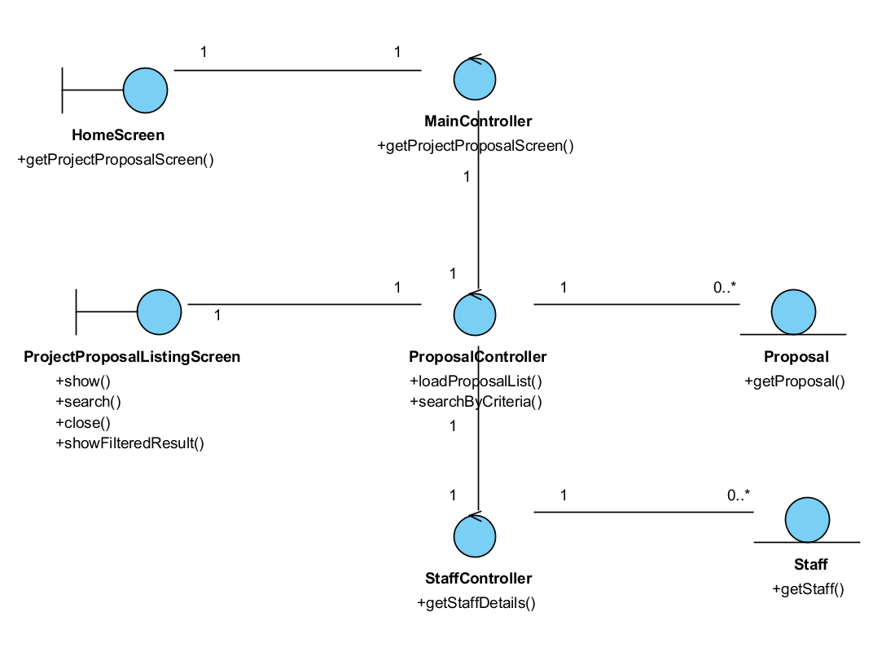

Figure 38 – m

ANNEX D Amendment History

This is a record of all amendments made to the Document.
Version | Chapter / Section | Page No | Notes of Amendments or Changes

